DATE: 14.06.2019
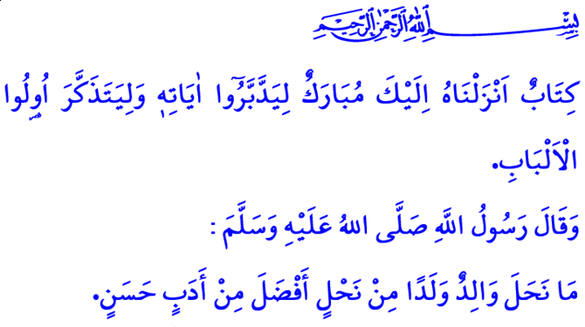
MOSQUES FULL OF CHILDREN,
CHILDREN FULL OF QUR'ANIC MANNERS
Honorable Believers!
Allah the Almighty (swt) states in the verse I have just recited: “This is a blessed Book which We have revealed to you so that they may contemplate its verses, and people of reason may be mindful.”
Prophet Muhammad (saw) reminded us in the hadith I have just read: “No father can leave a better heritage to his children than good manners.”
Dear Muslims!
Every child is born with the innate inclination to believe in, love, and be connected to Allah (swt). It is human nature to turn towards what is good, prefer what is pleasant, and search for the truth. The inner compass, since childhood, points to what is true and authentic. However, the paths children follow differ, their beliefs are formed, and their manners are changed as they grow up, under the influence of their parents and circle of friends.
Honorable Believers!
Our children are among the most precious blessings bestowed upon us by Allah (swt) that we need to hold in trust. Prophet Muhammad (saw) encourages us to appreciate the value of and look out for our children as rare treasures entrusted to us. There is a delicate balance of rights and responsibilities between parents and children. The greatest right our children have on us is for us to protect them from all kinds of evil by preserving their pure and uncorrupted nature.
Dear Believers!
Children are the apples of our eyes and hopes of our future, and therefore, we are responsible to meet their both non-material needs, as well as their material needs. Our fundamental duty is to ensure that our children are aware of the Almighty Allah (swt) and the Prophet Muhammad (saw), that they have acquired the habit of worship, and that they are instilled with good manners. We should embellish their innocent hearts and clear minds with knowledge, wisdom, and decency. We should keep them away from all kinds of perverted ideas, immoral behaviors, superstitions, and newly-emerging false forms of religious knowledge. We should exert efforts to rear them as sincere believers who lead their lives with the Holy Qur’an in their hands and iman in their hearts. We should not forget that it is the essential responsibility of each one of us to leave behind a beautiful young generation who is aware of the Book of Allah (swt), has the Messenger of Allah (saw) as role model, and is loyal to the homeland and fellow citizens.
Honorable Believers!
It is among the signs of being a believer to recite the Holy Qur’an finely, understand it in the most correct, way and live by it in every phase of one's life. It will be easier for our children to lead a life as described above if we ensure that they, from their early years on, are able to read the Qur’an, and are familiar with the core values of Islam. Our children are more, than any of us are, inclined to the warm and sincere call of the Qur’an, and to its spiritual offerings. Childhood is the best and most appropriate time to learn our sublime religion, to get the habit of worshipping, and to adopt such virtues as honesty and compassion. If we want to instill the love for the Qur'an in our children, and to ensure that they take the first steps into a life that will continue in the light of the Qur'an, the summer vacation is a unique opportunity.
Dear Muslims!
We would not like our children, who are easily attracted by the technology, to waste their days in front of computer and phone screens. Therefore, it is our duty to save our children from addiction to technology, and to create opportunities to strengthen their mental and physical health. One of the greatest opportunities to help develop the hearts of our children and enrich their dreams and ideals is around the corner. The summer courses are going to start at all of our mosques and Qur'an course centers on Monday, June 17th. Our mosques are going to spring up flowers, and our courses are going to be filled with joy, with our children, with the slogan of “Mosques Full of Children, Children Full of Qur'anic Manners". In addition to the lessons on iman, worship, and morals, our children will have fun while learning through social and cultural activities. We are waiting for your applications to our mosques and Qur'an courses in order to ensure that our children have "the most valuable heritage" of good manners as expressed by Prophet Muhammad (saw). We welcome our children, and pray for a successful, auspicious, happy, and healthy future for all of them.

Sad, 38/29.
Tirmidhi, Birr, 33; Ibn Hanbal, IV, 77. General Directorate of Religious Services

